Software Part
Download and install Python 2.6:
- Goto the folder Scara Softwares and double click on python-2.6.msi.
- Install it to D:\Scara\
- A new folder named “Python26” will be created in the above folder.
- Now you need to add python to your system path and also create PYTHONPATH.
- For this go to Start→ Search→ System→ Advanced System Settings→ Environmen Variables→ System Variables→ Path→ Edit. Add “D:\Scara\Python26” and “D:\Scara\Python26\Lib\site-packages\” to the path separated with semi-colon:

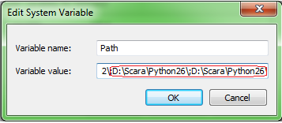

- Click Ok.
- Click New in Environment Variable dialogue box to create PYTHONPATH.

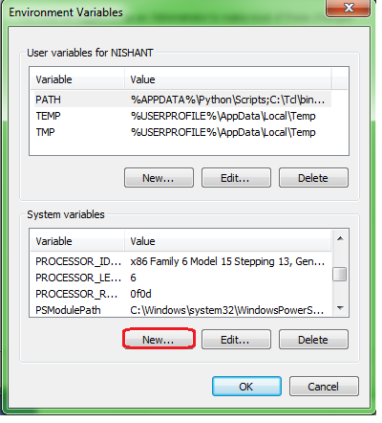
- Create the PYTHONPATH:

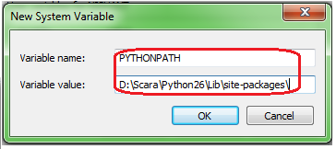

- Now you are ready to install all the modules required.
The following modules are required along with their functions:
- wxpython: GUI toolkit. Used for building the complete GUI.
- Zbar: Used for QR code scanning.
- OpenCV: Used for capturing video from camera, frame zoom in and zoom out, and basic pre-processing.
- Pyserial: Used for serial communication between python and controller.
- Numpy: Used for complex mathematical calculation and other important functions.
- Pyttsx: Python text to Speech converter for audio output.
- PIL: Python imaging Library. For working with images.
- Py2exe: for converting .py file into a distributable .exe application
- PyWin32: for using the windows text to speech converter.

All these modules are provided in the folder Scara Softwares. They all are compatible with python 2.6. In addition to these modules you required MinGW and ZBar windows application.

Installing OpenCV 2.4.5:

- Goto folder Scara Softwares copy the cv2.pyd file.
- Goto :D:\Scara\Python26\Lib\site-packages\” and paste cv2.pyd.

Installing Zbar:
- For this first you need to install MingGW and ZBar.exe
- Goto Scara Softwares. Double click on gcc-mingw-4.3.3-setup.exe.

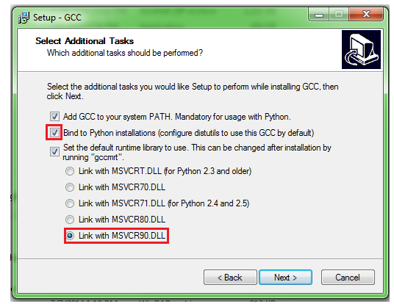

- MingGw will be installed in C:\Mingw. Add C:\MinGw\bin to system path.
- Now install Zbar. Goto Scara Softwares→ zbar-0.10-setup.exe. Install zbar to C:\

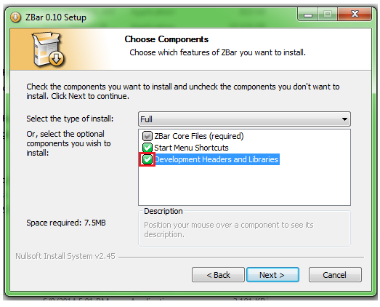

- Once installed add C:\Program Files\ZBar\bin folder to system path.

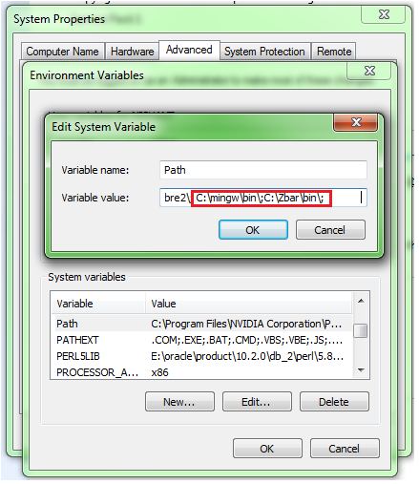

- Now to install zbar module. Goto Scara Softwares. Extract zbar-0.10.zip to D:\Scara\
- Goto directory D:\Scara\zbar-0.10. Edit the setup.py file. Right click on that file and select Edit with IDLE.
- Add ‘from distutils.sysconfig import get_config_vars’ to the third line of the program.
- Goto Line 43 in extension call and add the following lines:
library_dirs=["""C:\Program Files\ZBar\lib"""],
include_dirs=[get_config_vars('INCLUDEDIR'),
get_config_vars('INCLUDEPY'),
"""C:\Program Files\ZBar\include"""]
- Else directly copy the file from Scara Softwares→ Zbar Modify→ setup.py. And paste it to folder D:\Scara\zbar-0.10. Click Copy and replace.
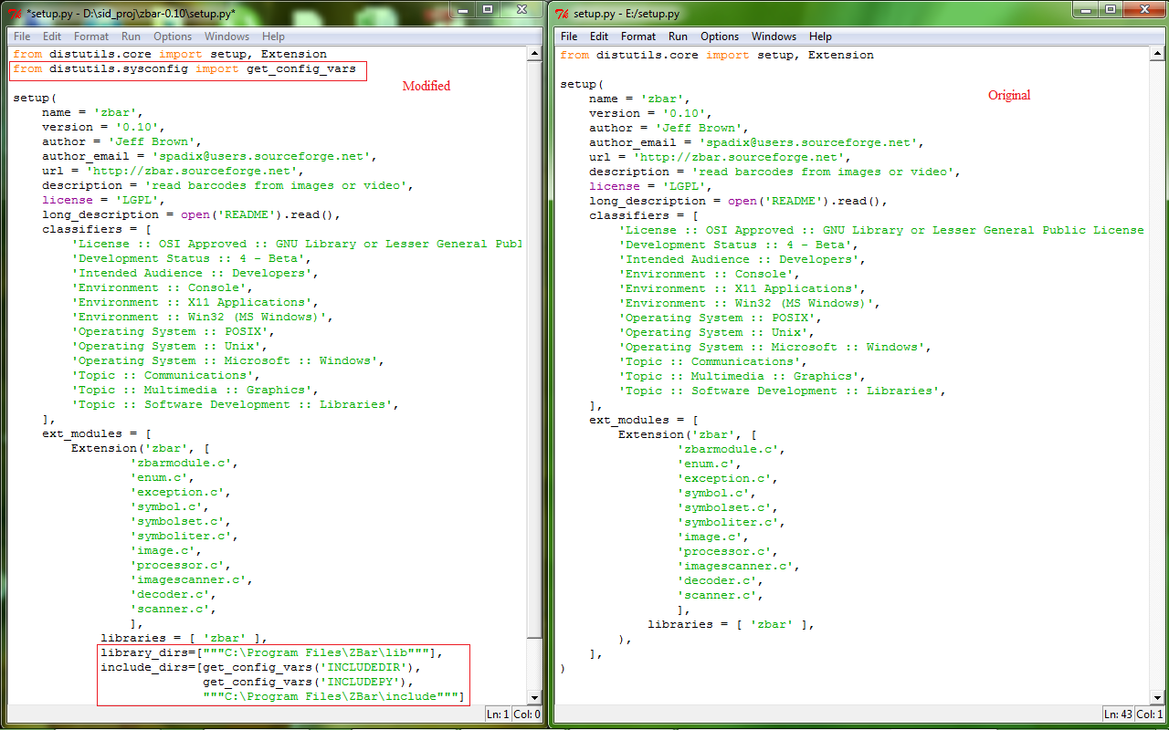

- Now open command Prompt.

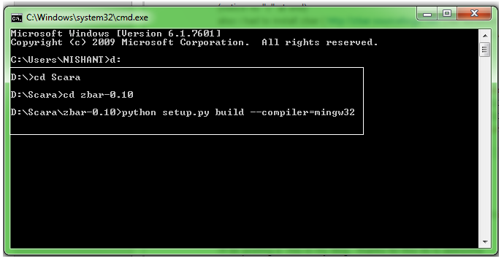

- Write the following commands on command prompt and press enter. To build type “python setup.py build –compiler=mingw32”. And then install using the command “python setup.py install”.
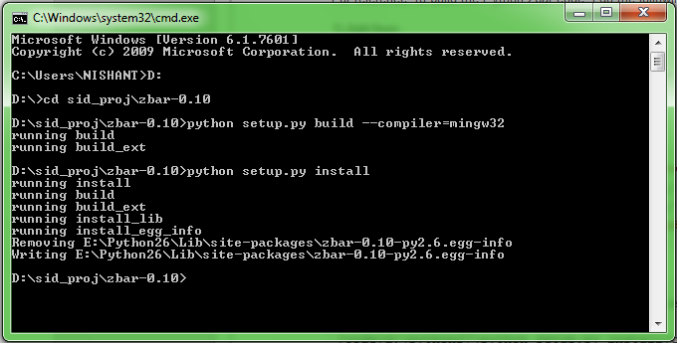

Installation of pyttsx:
- This is a complex part. I will myself show you the installation. Yet I am providing you the steps for any future reference.
- Goto Scara Softwares→ ProcessExplorer.zip. Open procexp.exe
- Click on View→ Lower Pane View→ Check on DLLs.
- The window should like this:

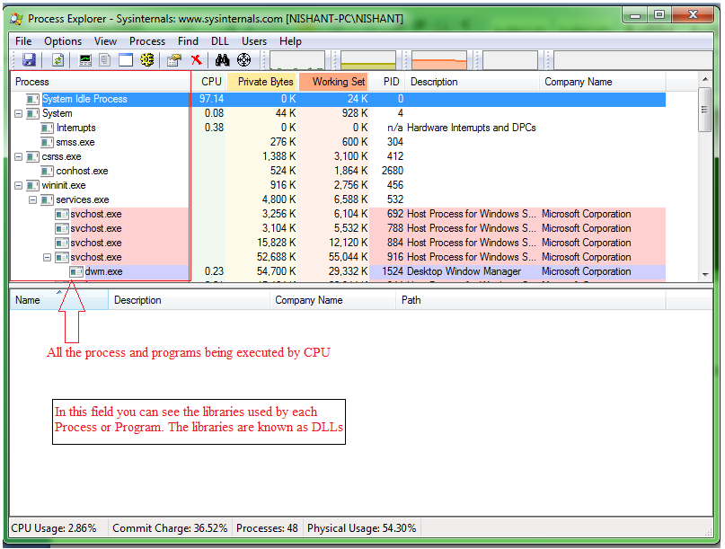
- Goto Scara Softwares→ pywin32-219.win32-py2.6.exe. Double click on it and try to install the file. It will give you an error message saying “Error R6034: An application has made an attempt to load the C runtime library incorrectly”.
- This happens because there are more than 2 paths from where the file msvcr90.dll file was being called by the installation process.
- Inorder to fix this again double click on pywin32-219.win32-py2.6.exe. As soon as you press next goto Process Explorer
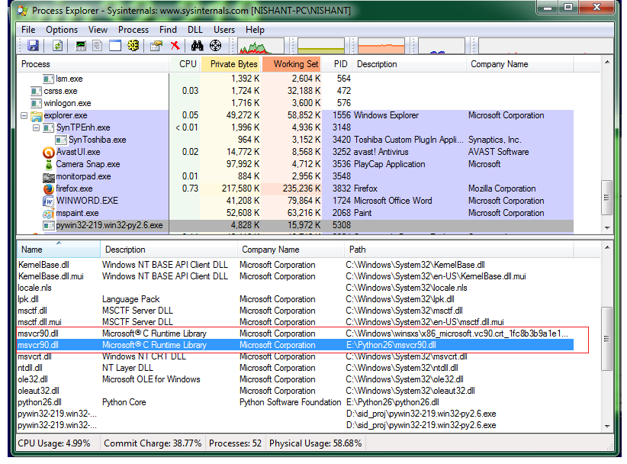

- As you can see. The library msvcr90.dll is being used from 2 different places which leads to a clash. Inorder to fix it select the msvcr90.dll file whose location is different from C:\Windows\winsxs\x86_...... In this case it is E:\Python26\msvcr90.dll. Goto that folder, temporarily delete the file msvcr90.dll. In this case I will goto E:\Python26\ and delete the file msvcr90.dll.
- Now again run the installation. This time it wont show you a windows error. But it will show you a python error.

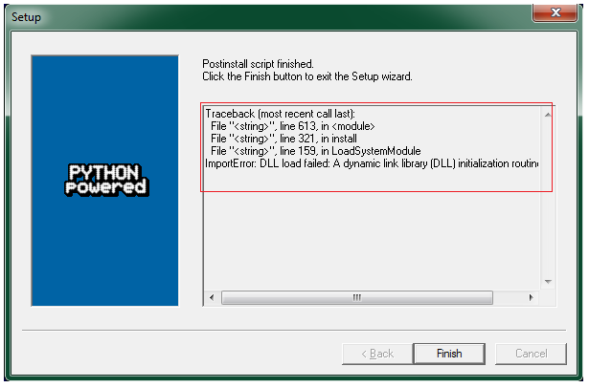

- Inorder to fix this goto D:\Scara\Python26 and search for the files pythoncom26.dll and pywintypes26.dll. They will be probably located in D:\Scara\Python26\Lib\site-packages\pyWin32 folder. Copy them from there and paste it to D:\Scara\Python26\Lib\site-packages\win32 folder.
- Now goto the folder Scara Softwares and install pyttsx. And you are done
- Just goto Python IDLE and execute import pyttsx. If no error pops up everything is fine.
- The rest of the modules can be installed easily to D:\Scara\Python26\Lib\site-packages.
- Once all the installation part is done you can go ahead with coding. Goto Python IDLE and run the following to confirm installation:
import cv2
import numpy
import zbar
import pyttsx
import serial
import math
import glob
import sys
import os
import time
If no error pops up everything is fine.

